KEYPAD DOOR UNLOCKING**

# **INTRODUCTION**

Welcome to my project of making a keypad door unlocking system. It works with help of ardino uno .The Arduino uno has been coded such that if you enter the right password then a door will be open with help of a servo motor.

# - **Parts Required**

1.- Arduino uno

2. Bread board

3. Lcd Display

4. Keypad 4*4

5. Jumper wires(male to male about 25 peices)

6. Buzzer

7. Servomotor

# - **Work of all different parts stated above _**

1. Let's start with **_LCD DISPLAY _**

- ​LCD DISPLAY is used to present to the users the different messages that guides him/her in using the project.

As we can see an 16*2 lcd display is being used in the project. The term 16*2 signifies that displaying 16 character over 2 lines. It's display screen glow with a green backlight. It can easily be operated on 5 voltage power, So it can be powered with help of Arduino Uno.

It has as many as 18 pins which can be seen in picture.

Starting from side we have 2 pins which which is used to power the back green light of the lcd. The rightmost pin named '**A**', '**K**' is also for the same purpose. The left most pins **VSS** and **VDD** is used for powering lcd displaying. The third pin named**VO** provides help in controlling the contrast of lcd display. The fourth pin is **register select** which is connected to a pin in Arduino board, the fifth pin is a called**Read Write** pin, it is grounded while sixth pin is the ** ENABLE ** which also occupies an pin on Arduino board.

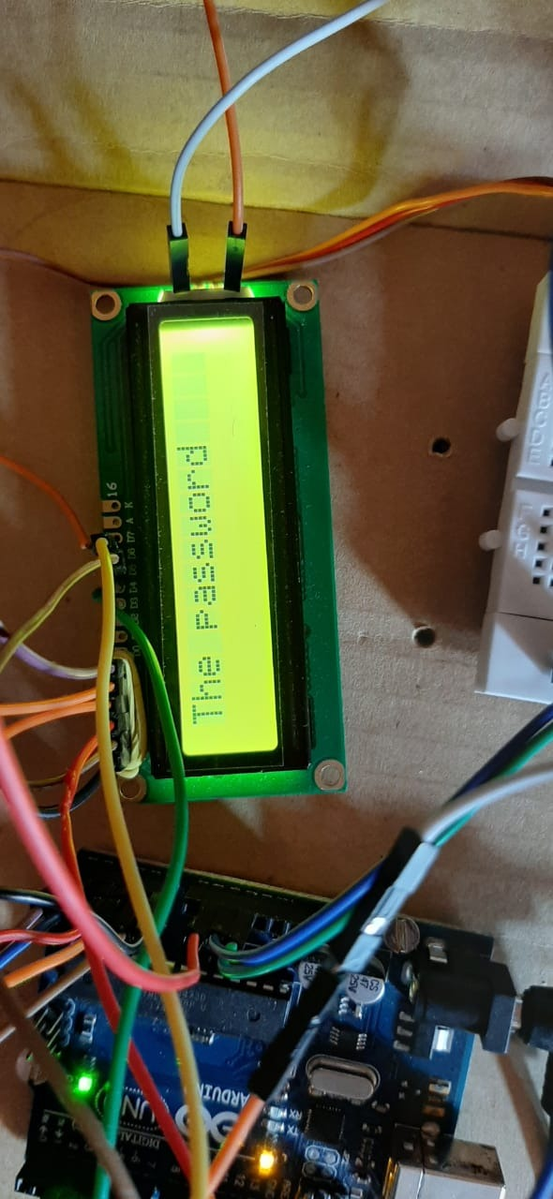

Here we have the lcd displaying the message to enter the password.

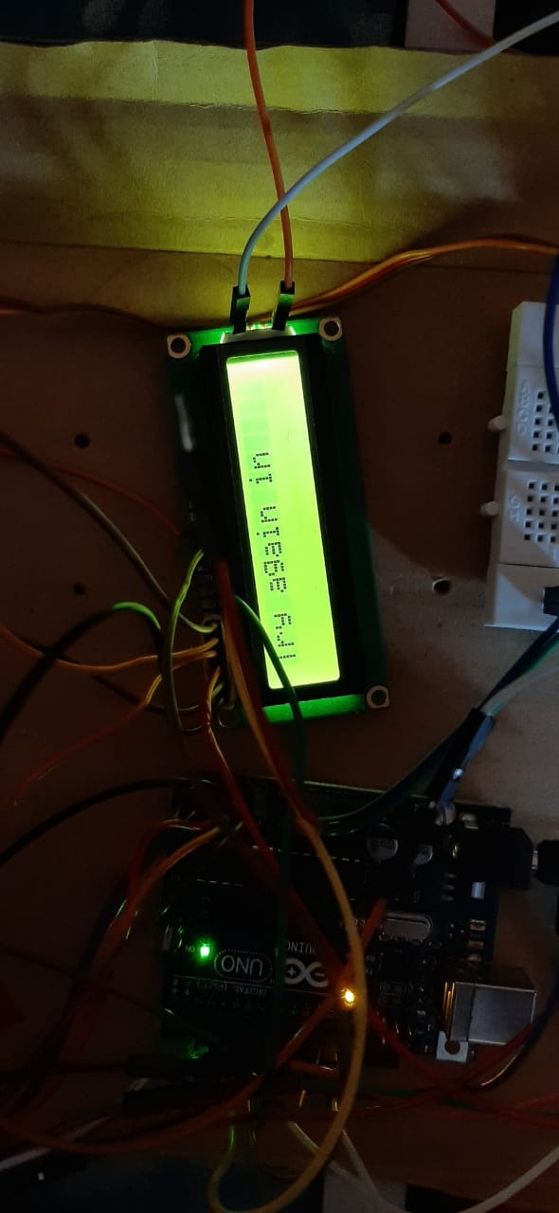

Here we can see lcd displaying the message to try again in case we have 3 wrong attempts.

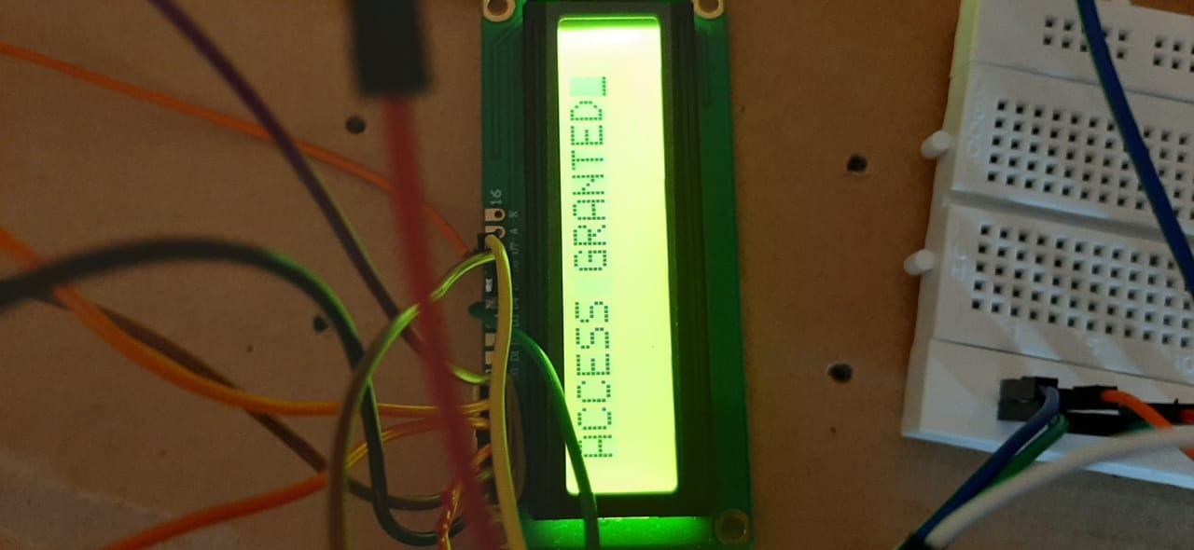

Here we can see lcd displaying the message that you have been gramted the the access as you have entered right password/

1. Now let come to KEYPAD

Keypad is used to enter the password in the system. 4*4 keypad is used here i.e. The keypad has 4 rows and 4 columns .It contains all the digits starting from 0-9.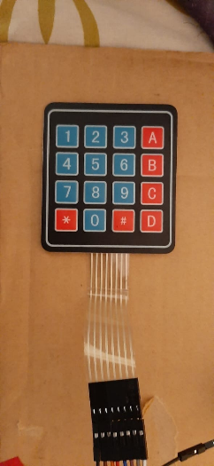

THE keypad used in the project.

1. SERVOMOTOR

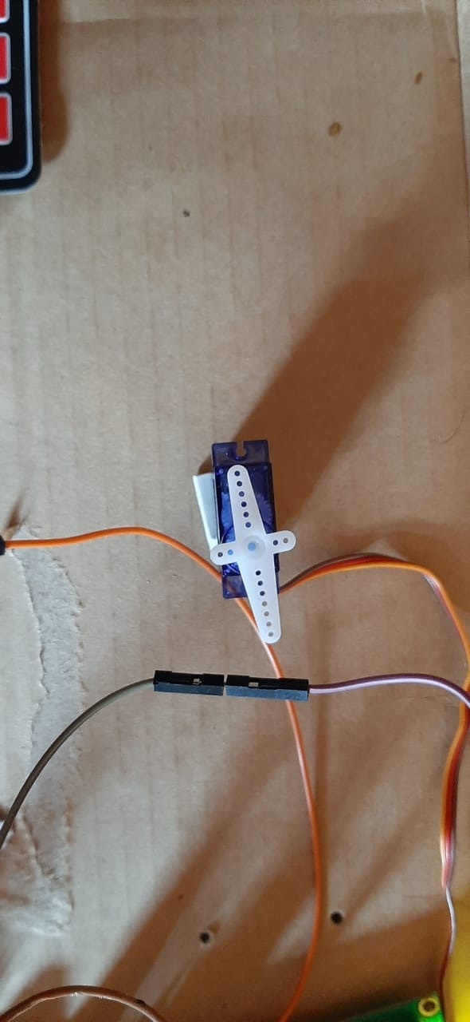

The servo motor that rotates by angle of 90 degree on entering the write password.

## THE CIRCUIT OF WHOLE PROJECT AND DIFFERENT COMPONENTS.

* LCD display.

|  |  |  |
| --- | --- | --- |
| SERIAL NUMBER | PIN NAME | CONNECTE TO |
| 1 | VSS | GROUNDED |
| 2 | VDD | SOURCE |
| 3 | VO | MIDDLE PIN OF POTENTIOMETER |
| 4 | RS | ANY PIN OF ARDUINO(C-12) |
| 5 | RW |  |
| 6 | E | ANY PIN OF ARDUINO(C-11) |
| 7 | D4 | ANY PIN OF ARDUINO(C-7) |
| 8 | D5 | ANY PIN OF ARDUINO(C-6) |
| 9 | D6 | ANY PIN OF ARDUINO(C-5) |
| 10 | D7 | ANY PIN OF ARDUINO(C-4) |
| 11 | A,K |  |

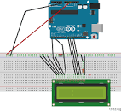

* KEYPAD CONNECTION
* Here is a table which tells about connection of keypad .WE have to make changes in codes accordingly.

|  |  |
| --- | --- |
| PIN (LEFT TO RIGHT) | USED FOR |
| 1st | ROW1(C_A0) |
| 2nd | ROW2 (C_A1) |
| 3rd | ROW3(C_A2) |
| 4th | ROW4(C_A3) |
| 5th | COLUMN 1(C_A4) |
| 6th | COLUMN 2(C_A5) |
| 7th | COLUMN 3(C_2) |
| 8th | COLUMN 4(C_3) |

1. SERVO CONNECTION

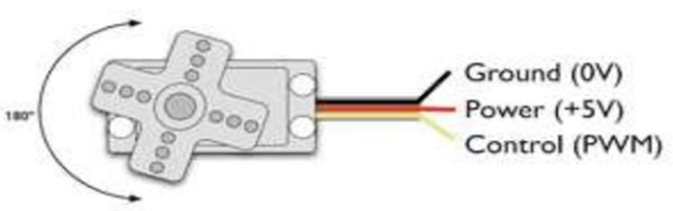

The control pin has been connected at pin 9.

1. BUZZER

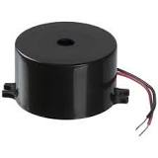  
One end of the Buzzer is connected to the pin 8 of Arduino Uno whereas the other pin is connected to ground.

## CODES FOR THE PROJECT

Before coming to the main code we will first go through the different functions that have been used in the code.

THE LCD DISPLAY FUNCTION USED

|  |  |
| --- | --- |
| Function used | Work |
| lcd.begin() | **begin()** needs to be called before any other **LCD** library commands. |
| lcd.clear() | Clear the display screen |
| Lcd.print() | Print on the screen |
|  |  |

THE KEYPAD FUNCTION USED

|  |  |
| --- | --- |
| Function used | Work |
| keypad.waitForKey() | Wait for the user to press a key.  The whole program will not proceed any further  Unless a key is pressed |

THE EEPROM(Electrically Erasable Programmable Read-Only Memory) FUNCTION USED

|  |  |
| --- | --- |
| Function used | Work |
| EEPROM.read(i) | It read the value stored in the ith memory location. |
| EEPROM.write(i) | It writes the value in the ith memory location. |
|  |  |

|  |  |
| --- | --- |
| Other Function used | Work |
| delay(t) | Does not proceed in the code for t milliseconds |
| servo.attach(i) | Connects the servo motor to ith pin |
|  |  |

### THE MAIN CODE

#include <Keypad.h>//including the keypad library

#include <LiquidCrystal.h>//including the liquidCrystal library

#include <EEPROM.h>//including the EEPROM library

#include <Servo.h>//including the Servo library

//INCLUDING ALL THE LIBRARIES

LiquidCrystal lcd(12,11,7,6,5,4);

char keys[4][4]=

{{'1','2','3','A'},

{'4','5','6','B'},

{'7','8','9','C'},

{'*','0','#','D'}};

byte rowpins[4]={A0,A1,A2,A3};

byte colpins[4]={A4,A5,2,3};

Keypad keypad=Keypad(makeKeymap(keys),rowpins,colpins,4,4);

Servo myservo;

char pwd[4],tpwd[4];

int wrg=0;int b=8;

// CHANGE FUNCTION

void change()

{lcd.clear();

delay(500);

lcd.print("Enter the password");

lcd.setCursor(0,1);

for(int i=0;i<4;i++)

{

char s=keypad.waitForKey();

if(s){

EEPROM.write(i,s);}

lcd.print("+");

}

delay(1000);

lcd.clear();

getpwd();

}//end of change function

/*CHANGE FUNCTION is used to alter the password that has been stored in the eeprom*/

// GRTPWD FUNCTION

void getpwd()

{ lcd.print("LOADING....");

for(int i=0;i<4;i++)

{charexg(i);}

delay(2000);

lcd.clear();

} //end of getpwd

/*getpwd FUNCTION has been defined to get the value of password that haas been stored in EEPROM*/

// CHAREXG FUNCTION

void charexg(int a)

{int e=EEPROM.read(a);

pwd[a]=(char)(e);

}// end of charexg

void servomo(){

for (int pos = 0; pos <= 90; pos += 1) { // goes from 0 degrees to 180 degrees

// in steps of 1 degree

myservo.write(pos); // tell servo to go to position in variable 'pos'

delay(50); // waits 15ms for the servo to reach the position

}

}//servomo is defined to turn the servo motor by 90

// SETUP FUNCTION

void setup()

{Serial.begin(9600);

lcd.begin(16,2);

if(EEPROM.read(100)==0)

/*this if has been used to check if EEPROM already has a stored password or not

* if value at 100 is 0 that means there is no password stored

* but if value at 100 is not 0 that means there is a passsword stored,so it skip to else

*/

{lcd.print(" WELCOME ");

delay(500);

change();

EEPROM.write(100,1);

}// end of if

else

{getpwd();

}// end of else

pinMode(b,OUTPUT);

myservo.attach(9);}//end of setup

// LOOP FUNCTION

void loop()

{ lcd.clear();

delay(500);

if(wrg<3)

{int i;

lcd.print("The password");

lcd.setCursor(0,1);

for( i=0;i<4;i++)

{ char s=keypad.waitForKey();

tone(b,4500);

delay(100);

noTone(b);

if(s=='*')

{change();

break;}

tpwd[i]=s;

if(pwd[i]!=tpwd[i])//

{ lcd.print("+");

delay(1000);

lcd.clear();

lcd.print("ACCESS DENIED");

tone(b,427);

delay(500);

noTone(b);

delay(500);

wrg++;

break;}

else

{lcd.print("+");

}

if(i==3)

{lcd.clear();lcd.print("ACCESS GRANTED"); servomo();delay(5000);}

}//end of for loop

}//end of if

else

{lcd.clear();

lcd.print("Try again in");

for(int i=30;i>0;i--)

{lcd.setCursor(0,1);

lcd.print(i);

delay(1000);

}//end of for loop

wrg=0;

}// end of else

}

// end of loop function